AppDirect Sign up Automation Demo

- Environment Setting
  - Eclipse: Eclipse Java EE IDE for Web Developers. Version: Mars Release (4.5.0) Get it from: https://www.eclipse.org/downloads/
  - Java version:
java version "1.8.0_60"
Java(TM) SE Runtime Environment (build 1.8.0_60-b27)
Java HotSpot(TM) 64-Bit Server VM (build 25.60-b23, mixed mode)

- Libraries
  - Selenium: selenium-java-2.46.0 (please download it from http://www.seleniumhq.org/download/ (higher version should be good but only tested with 2.46.0)
  - TestNG: 6.8.21
  - Optional: javamail-1.4.7 (required by activation link test only)

- How to run it
  - Import all .java files under /scr folder to a new or existing project.
  - Make sure all required libraries are set up properly.
  - Right click a class and select “TestNG Test”
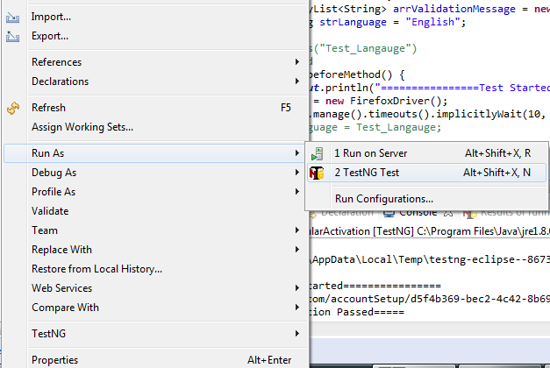
- AppDirect_RegularSignUp.java: all parameters will be created dynamically
- AppDirect_Yahoo.java: need to set up a brand new Yahoo account: email address and password.
Line 63: email address
Line 64: password
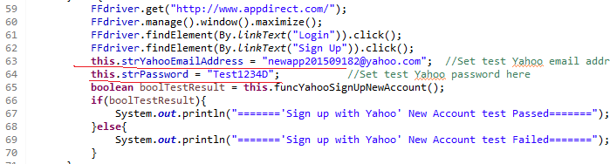

  - AppDirect_Yahoo_OldAccount.java: all parameters were set up. However, it is open for any other Yahoo account which is already registered with AppDirect.
Line 63: email address
Line 64: password
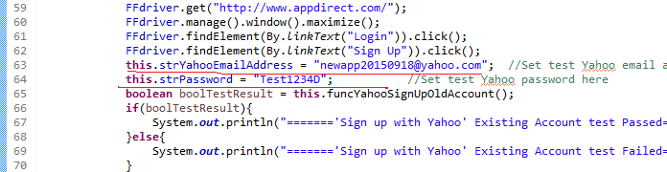

Optional: AppDirect_RegularActivation.java: need to set up a brand new Gmail account: email address and password
Line 33: email address
Line 34: password

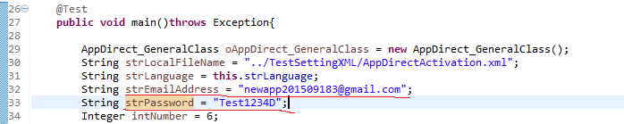
- Code Explanations
4.1 AppDirect_GeneralClass.java: this class provides 2 public functions: funcGetProjectTerms(String strFilePath,String strLanguage, Integer intNumber) and funcGetActivationLink()
a. public boolean funcGetProjectTerms(String strFilePath,String strLanguage, Integer intNumber): this function will parse a given .xml file and send all <message> strings to a <ArrayList> arrValidationMessage. The .xml file should be located under the project folder when it is a relative path or please use an absolute path.
- strFilePath is used for the path
- strLanguage is used for the .xml tag <Language>. It is designed for UI localization
- intNumber is used for determining how many message strings to get. It must match the .xml file <message> tag.
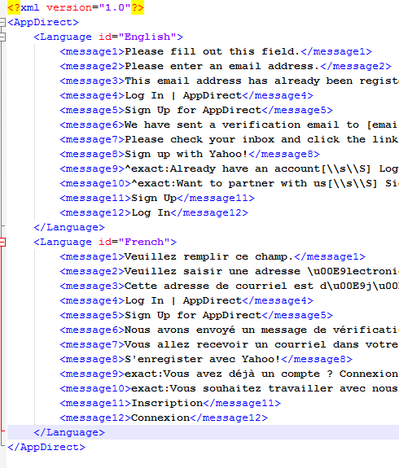
b. funcGetActivationLink(): This function automatically accesses into Gmail account by given Gmail account credential and finds the most recent email. If the most recent one is the AppDirect activation email, it returns a proper activation link; if it is not, it returns a empty string.

4.2 AppDirect_RegularSignUp.java: this class does automatic test for regular sign up work flow, both valid sign up and invalid sign up.
a. Validation sign up: funcValidSignUp(). It acts a user to open a Firefox browser and get appdirect.com. When the page is loaded, it automatically maximize the browser page -> clicks “login” -> clicks “Sign up” -> fill the form with a dynamically generated email address -> clicks “Sign up” -> verify confirmation message
b. Invalid sign up: funcInvalidInputValidation(String strInput, String strBaseline, int intMessageIndex) It is a little bit trick to validate error messages on sign up page because it is using Webshim + HTML 5 to prompt error messages, which is not located within the page DOM. Thus, it is a little bit hard to get message strings from the page. The code did the validation through the code level. When there is an error message triggered, the input field class will be changed to “form-ui-invalid” and a related message will be found from JavaScript code. So the function simulate an invalid input and checks source code to make sure the particular class name is changed and related message was found. It may not be able to catch all cases but works for most of cases after couple of testes were run and confirmed.
- strInput: the invalid input, which could be empty string or any other string.
- strBaseline: the pre-defined elements to find related error message
- intMessageIndex: the message index number to get related error message from <arrValidationMessage> list. The returned message string is used to compare with message string got from source code to make sure the proper message is loaded.

4.3 AppDirect_Yahoo.java: this class does validation of a new Yahoo account signing up with Yahoo tunnel. Once Yahoo email address and password are given, the funcYahooSignUpNewAccount() automatically goes through “Login” -> “Sign up” -> “Sign up with Yahoo” -> fill the form and un-check “Please keep me sign in” checkbox -> “Sign in” -> validate the “Activate your account” string to make sure it redirects to a right destination. Of course it could do more validations on this page, for example, inputs validation, UI validation and so on. All those validations belong to “Activate account” page which can be done separately.

4.4 AppDirect_Yahoo_OldAccount.java: this class checks an error message when it tries to sign up through Yahoo tunnel with a Yahoo account which is already registered with AppDirect. The entire work flow is similar to previous tests.

4.5 Optional: AppDirect_RegularActivation.java: it finishes regular sign up with a brand new email address by given a proper Gmail account and then it gets into Gmail programmatically and tries to get AppDirect activation link. If the link is caught properly, the code triggers that link and validate “Activate account” page, similar to Yahoo account.

Important: driver.quit() is not used because Selenium Webdriver encounters errors on Firefox (version 30 and higher). To run tests properly, please manually close Firefox browsers after each test.

There are a lot of tests and validations can be done for sign up page and related pages, such as UI location string validation, link redirection validation and so on. Unfortunately, I really didn’t have much time to work on it.

Here is a sample of the AppDirect_RegularSignUp test outputs. Please check the result “Passed” or “Failed”.

[TestNG] Running:
C:\Users\chong.xiang\AppData\Local\Temp\testng-eclipse--1654337523\testng-customsuite.xml

================Test Started================
Page Title Compare is correct
Page Title Compare is correct
===Test Valid Sign Up Started===
Sign Up with new email address 2015-09-20_13_18_20@test.com
strDefaultMessage is We have sent a verification email to 2015-09-20_13_18_20@test.com.
Good 1
Good 2
===Test Valid Sign Up Passed===
===Test Empty Input Started===
Default field was loaded
Error class was caught
Error message is correct
===Test Empty Input Passed===
===Test Invalid Input 1 Started===
Default field was NOT loaded
Error class was caught
Error message is correct
===Test Invalid Input 'sdfdsfdsfdsfds' Passed===
===Test Invalid Input 2 Started===
Default field was loaded
Error class was caught
Error message is correct
===Test Invalid Input 'test@test' Passed===
===Test Invalid Input 3 Started===
Default field was loaded
Error class was caught
Error message is correct
===Test Duplicated Input Passed===
================Test Completed================
PASSED: main

===============================================
Default test
Tests run: 1, Failures: 0, Skips: 0
===============================================

===============================================
Default suite
Total tests run: 1, Failures: 0, Skips: 0
===============================================

[TestNG] Time taken by org.testng.reporters.SuiteHTMLReporter@21588809: 49 ms
[TestNG] Time taken by org.testng.reporters.jq.Main@12bb4df8: 33 ms
[TestNG] Time taken by org.testng.reporters.XMLReporter@7b3300e5: 4 ms
[TestNG] Time taken by org.testng.reporters.EmailableReporter2@6a38e57f: 11 ms
[TestNG] Time taken by org.testng.reporters.JUnitReportReporter@4ac68d3e: 5 ms
[TestNG] Time taken by [FailedReporter passed=0 failed=0 skipped=0]: 0 ms

